**Lesson 07 Demo 8**

**Create an S3 Bucket Using Terraform**



**Steps to be performed**

1. Set up Terraform components
2. Create Terraform execution plan

**Step 1: Set up Terraform components**

1.1 Run the below commands in the given sequence to set up the Terraform component:

***pip install awscli***

***sudo apt-get update***

1.2 Create a new file to execute this project.

***mkdir s3back***

***cd s3back***

**Step 2: Create a Terraform execution plan**

2.1 Create **creds.tf** under **s3back** and add the code given below:

***nano creds.tf***

2.2 Paste the below code:

***provider "aws" {***

***access_key = ""***

***secret_key = ""***

***token = ""***

***region = "us-east-1"***

**}**



**Note**: Use the AWS access credentials provided in the AWS API Access tab in your LMS in your PRACTICE LAB tab as shown in the screenshot below:

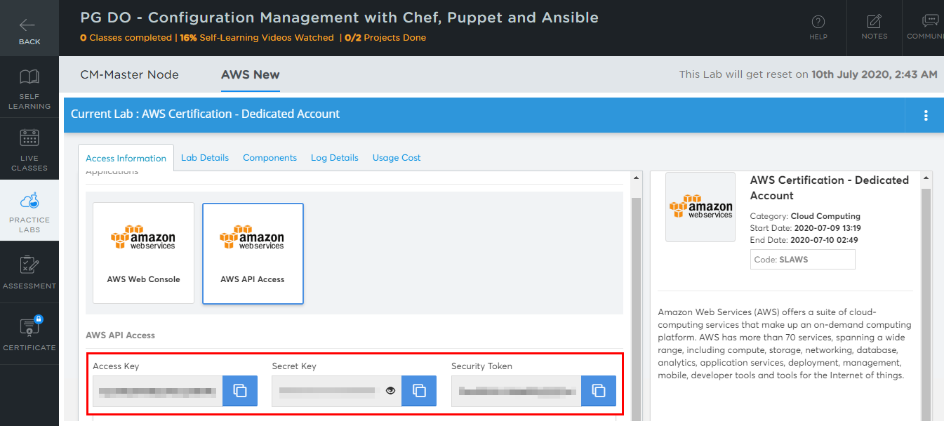

AWS access credentials will change when the AWS Lab session expires, every four hours.

2.3 Create **main.tf** under **s3back** and run the code given below:

***nano main.tf***

2.4 Paste the below code:

***resource "aws_s3_bucket" "b" {***

***bucket = "my-tf-test-bucket"***

***acl = "private"***

***tags = {***

***Name = "My bucket"***

***Environment = "Dev"***

***}***

***}***

**Note:** Bucket name entered here should be unique globally otherwise it may throw an error while executing the script.

2.3 Run the below commands in the given sequence to add the AWS providers:

***terraform init***

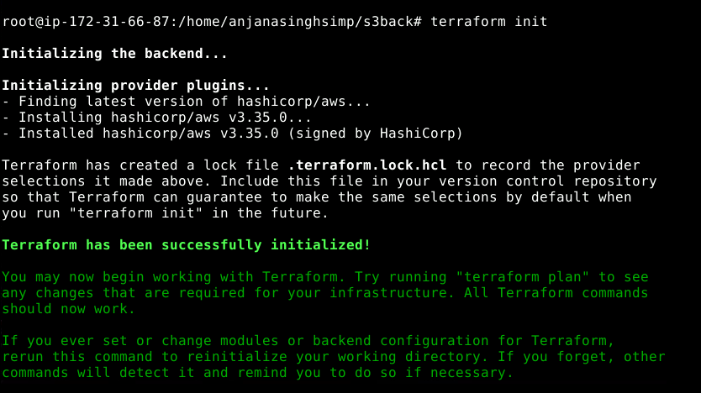

2.4 Run the command given below to commit TF state:

***terraform plan***

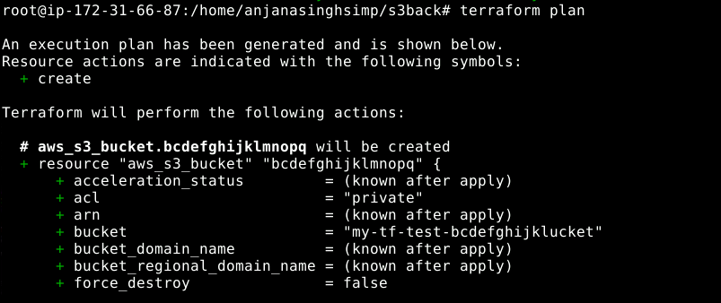

***terraform apply***

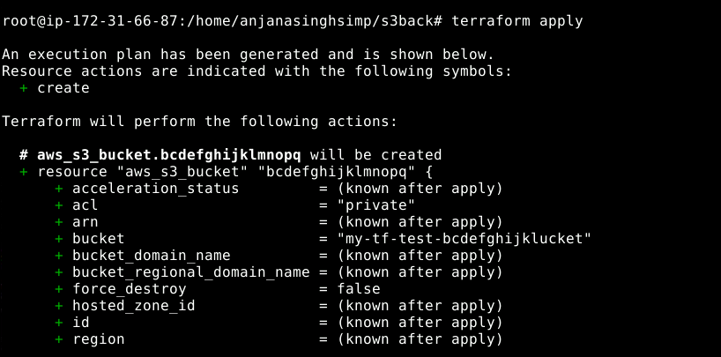

**Enter a value**: Yes

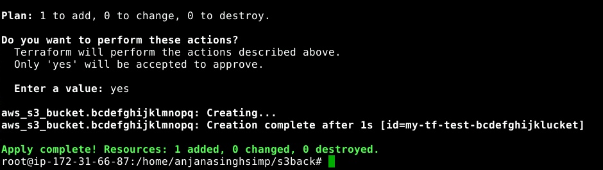

2.5 Verify the creation of S3 bucket in the AWS Management console

